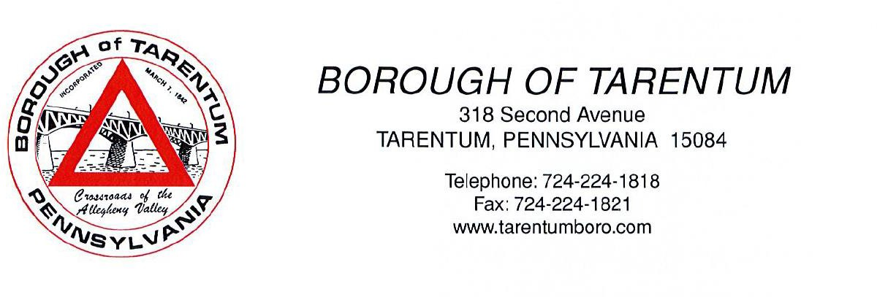

PUBLIC HEARING NOTICE
FOR: Conditional Use
Location: 344 West 9th Avenue, Tarentum, PA 15084
PARCEL NUMBER – 1223-N-00090-01

Tarentum Borough Council will conduct a public hearing on Tuesday, April 2, 2024, at 5:45 PM, in the Borough Council Chambers, 318 2nd Avenue, Tarentum, Pennsylvania 15084, for conditional use of property 344 West 9th Avenue, Tarentum, PA 15084

All interested parties and / or persons are urged to attend and state their views.

Dwight Boddorf
Tarentum Borough Manager

